Antonio Moreno

Meal Squad: A Class Exercise in Multi-Agent Systems

Today you’ll work on an agent system that creates a varied and affordable five-day dinner plan. In groups, you’ll build AI agents in Lovable and connect them into a system in which each agent does one job and hands its work on to the next.
The exercise lets you learn by building. Along the way you’ll see how agents:
- receive instructions and goals, and decide for themselves how to reach them;
- use tools and real data, rather than making things up;
- follow rules they read from a shared server using MCP, instead of having them written into their code;
- hand their work to other agents through a coordinator;
- deal with rejections, surprises and failures, and explain them honestly.
The goal is understanding, not a perfect system. Agent responses may be inconsistent, handoffs may not work as expected, and some steps may fail. That’s part of the process: pay attention to what works, investigate what doesn’t, and use each result as an opportunity to improve your system. Everything you need is also on the exercise site, https://recipes-delta-red.vercel.app, where the sample prompts come ready to copy with your group name filled in.

The Challenge
The task is simple to state and hard to do well: five dinners, Monday to Friday, that are varied and within a budget. The recipes are real, from TheMealDB, and the prices are real Kroger prices. No single agent does it all: each one does one job and hands its work on.

Figure 1 Today’s challenge
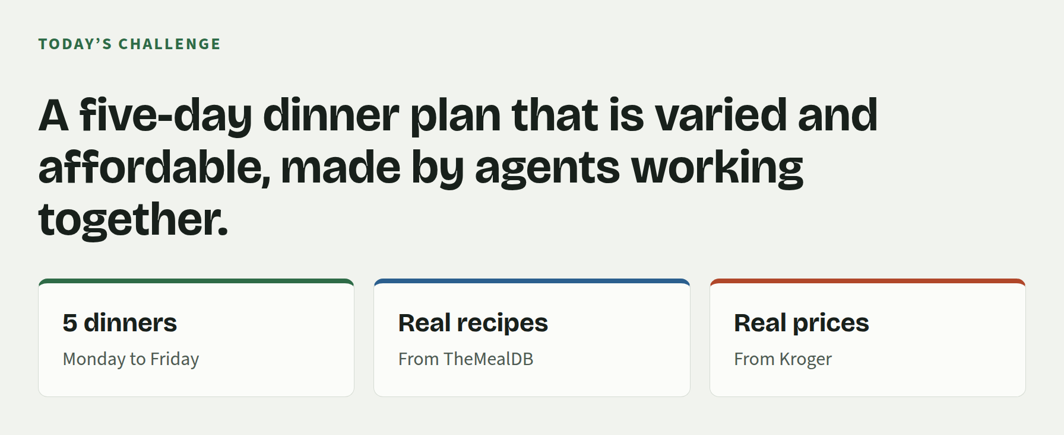
Source: Meal Squad class slides.

The Agent System
The system has four agents and a coordinator. The first agent, the Recipe Scout, researches and proposes recipes. The second, the Recipe Pricer, calculates the cost of each recipe; it has already been built. The third, the Meal Planner, creates a five-day plan using the priced recipes. The fourth, the Shopper, chooses the class’s best plan and builds its Kroger cart; it has also been built already. Every group builds a Recipe Scout; groups that have time go on to build a Meal Planner.

Figure 2 Four agents and the coordinator that connects them
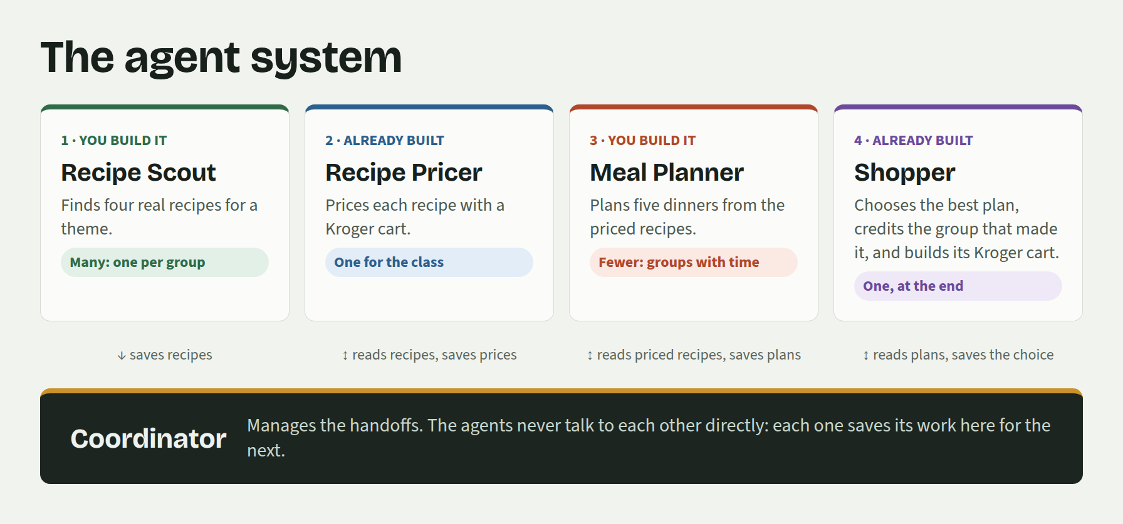
Source: Meal Squad class slides.

What Is an Agent?
An action (also called a tool) performs one specific task: search for a recipe, look up its ingredients, save it. It is ordinary code that always does the same thing. An agent is an AI model with a goal, a set of tools and a loop: it decides which actions to use and in what order, looks at each result, and decides what to do next until the job is done, or stops and explains why it can’t finish.

Figure 3 An action and an agent
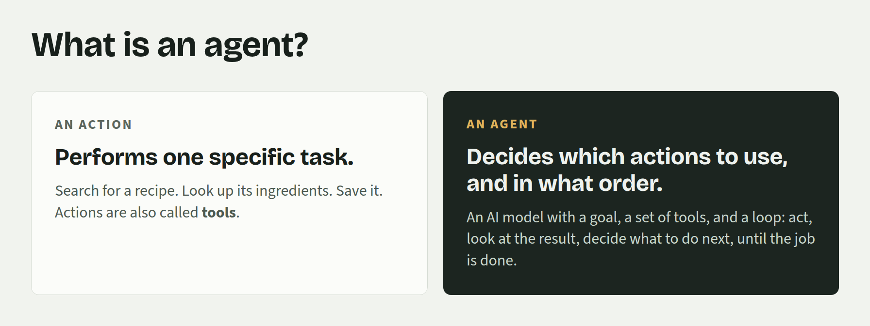
Source: Meal Squad class slides.

The Coordinator
The coordinator is the shared hub of the system. The agents never talk to each other directly: each one connects to the coordinator using MCP, learns from it which tools it offers and how to use them, and saves its results there for the next agent. The coordinator checks everything it receives (the format, that recipes are real TheMealDB recipes, the limits and the class’s rules for a meal plan), works out the numbers itself so that no agent can make one up, and explains any rejection, so that an agent can fix its mistake and try again. Every request and answer appears, live, on the site’s Coordinator page.
The coordinator is not an agent: it uses no AI. It is ordinary code that follows fixed rules and gives the same answer every time. That split is deliberate. Agents use judgement, which is flexible but can be wrong; the coordinator gives them firm ground, with rules that can’t be talked around. The coordinator could be an agent too: many systems use an AI “orchestrator” that decides which agent works next and reviews their work. That makes a system more flexible, but less predictable and harder to check.

Figure 4 How an agent works with the coordinator using MCP
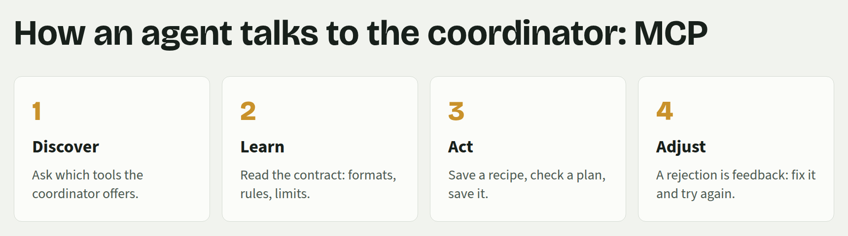
Source: Meal Squad class slides.

Real Data
The recipes come from TheMealDB, a free, open database of real recipes with photos, ingredients and instructions; your Scout Agent calls it from your Lovable app’s backend with the free developer key “1”. The prices come from Kroger’s API, which needs credentials, so only the agents that run on the coordinator site use it. The Recipe Pricer prices every recipe per person: the cost of one serving when the recipe is cooked for many people. At the end, the Shopper Agent scales the chosen plan to the number of people shopping (50 by default) and turns it into one Kroger cart for the week. Prices are estimates when Kroger has no match, and they are labelled as such.

Figure 5 The two sources of real data
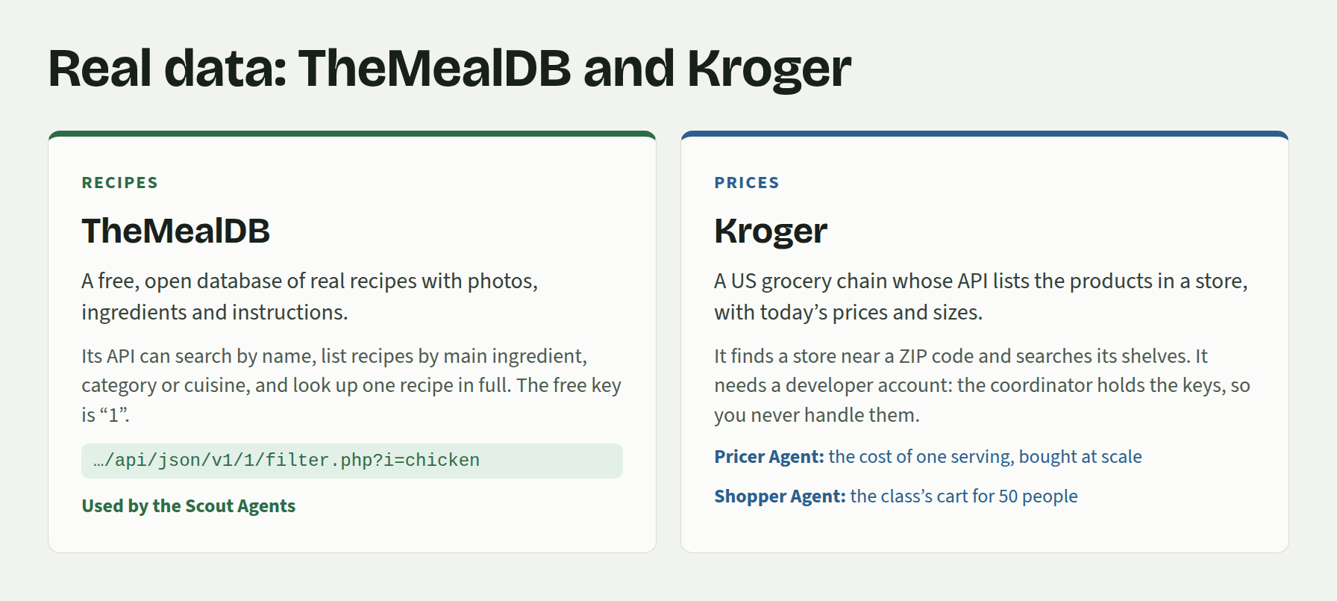
Source: Meal Squad class slides.

Before You Start
- Work in groups of two or three: one person builds, and everyone watches the same screen and helps.
- Open Lovable (lovable.dev) on the builder’s screen and log in.
- Choose a unique group name, for example team-3, and type it on the site’s Welcome page: the site’s prompts then fill it in for you. In this document the prompts show [your group name] instead: replace it with your group’s name.
- Check the class key your instructor gives you on the Welcome page. The class key goes into a Lovable secret when a prompt asks for it, never into a prompt, your page or a chat.

Working in Lovable
- Start a new project: in Lovable, go to Projects, then New project. The Recipe Scout gets a project of its own, separate from the Meal Planner.
- Use Build mode. Make sure Lovable is set to Build when you paste a prompt, so that it writes the code. In Plan mode it only talks the change through.
- Approve Cloud. If Lovable asks to enable Cloud, approve it: the app needs a backend to reach recipes and the coordinator.
- Paste one step at a time and check the result before moving on.

Figure 6 Starting a project in Lovable, and the Plan / Build switch
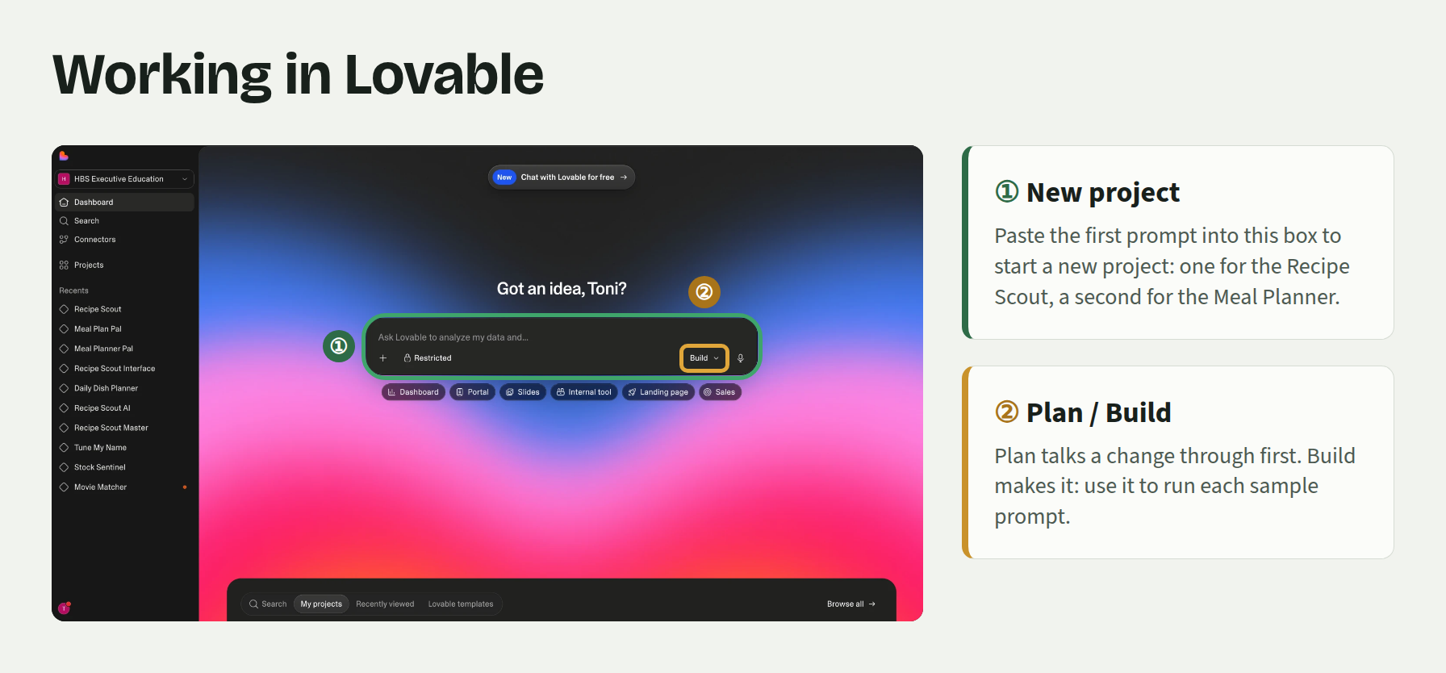
Source: Meal Squad class slides; Lovable screenshot.

How Each Step Works
Every step below has the same four parts: a goal (what the step adds, and why); a sample prompt to copy into Lovable, as it is or changed to make the app your own; what you should see (check it before moving on); and things you can try. The things you can try are where most of the learning happens: try to break your agent, and see whether it explains itself honestly.

Part 1: The Recipe Scout (Agent 1)
The Recipe Scout finds real recipes that fit a dinner theme and saves them to the coordinator. You build it in five stages: first a plain page, then ordinary actions that search TheMealDB, then the Scout Agent that decides how to use them, and finally the connection to the coordinator, so its recipes can be priced and used by the other agents.

Figure 7 What the Scout Agent does
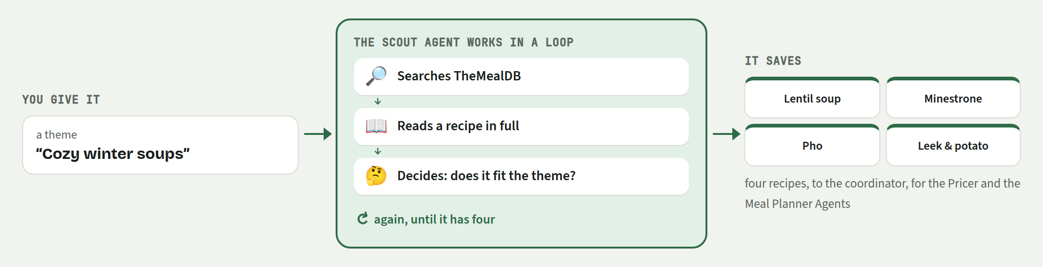
Source: Meal Squad site, Recipe Scout page.

Step 0 (warm-up): Build your first page
Goal. See how quickly Lovable can turn a plain-language description into an interface. There is no AI, backend or recipe data yet.
Sample prompt (copy it into Lovable as it is, or change it)
Create a web page for an application called “Recipe Scout.”

Recipe Scout is one part of a class project in which several apps work together to plan a week of dinners. We are building only Recipe Scout. Its one job is to find recipes: it does not plan meals, choose days or calculate prices. Other apps do that.

Recipe Scout will eventually use AI to:

- Take a dinner theme from the user
- Search a real recipe database
- Find exactly four recipes that fit the theme
- Examine each recipe before selecting it
- Send the selected recipes to a coordinator, which passes them on to the other apps

For now, build only the interface. Do not add AI, a backend, a database or connections to other services yet.

Include:

- A welcoming title and a short explanation of what Recipe Scout will do
- A box labeled “What kind of dinners are you looking for?”
- These clickable examples:
- Cheap vegetarian weeknight dinners
- Comfort food for a rainy day
- Dinners ready in about 20 minutes
- A “Scout recipes” button
- An empty area with space for four recipe cards, where the selected recipes will eventually appear

Nothing needs to happen when the button is pressed yet.

Make the page warm, inviting, responsive and accessible.

What you should see
- A finished-looking page with a theme input, example themes, a button and an empty results area. It is normal that the button does nothing.
Things you can try
- Ask Lovable to change the colors or visual style.
- Add another example dinner theme.
- Change the title or button text.
- Ask Lovable to make one small layout improvement.
Don’t spend too long polishing. You will change the interface as the agent develops.

Step 1: Connect to real recipe information
Goal. Give the application reliable actions for finding real recipes. These are ordinary backend functions—not an AI agent.
Sample prompt (copy it into Lovable as it is, or change it)
We are going to use TheMealDB API to find real recipes. Read and follow the implementation instructions at:

https://www.themealdb.com/AGENTS.md

Use TheMealDB’s free developer key, which is the number 1, as in https://www.themealdb.com/api/json/v1/1/search.php?s=soup

Enable Lovable Cloud. All requests to TheMealDB must be made from the backend.

Do not add an AI agent yet.

Create backend actions that can:

- Search for a recipe by its name
- Find recipes containing a particular main ingredient
- Find recipes in a category, such as Vegetarian or Seafood
- Find recipes from a cuisine or country
- Retrieve the complete details of one recipe

Search and filter results should include the recipe’s ID, name and photo. Complete recipe details should also include its ingredients, measurements and instructions.

If nothing is found, return an empty result instead of showing a technical error.

Add a temporary area called “Recipe Tool Lab” below the existing Recipe Scout page. Let me choose one of the recipe actions, enter a search value and see the result. Explain that this is a testing area that may be removed later.

Follow all attribution and linking requirements in TheMealDB’s instructions.

What you should see
- The original Recipe Scout page
- A temporary Recipe Tool Lab
- Real recipes returned from TheMealDB
- Ingredients and instructions when retrieving a complete recipe
Things you can try
- In the Recipe Tool Lab, search by name for Arrabiata.
- In the Recipe Tool Lab, search using the ingredient chicken.
- In the Recipe Tool Lab, browse the category Vegetarian or the cuisine Italian.
- In the Recipe Tool Lab, search for something that probably does not exist.
Notice the difference between an action and an agent. An action performs one specific task. An agent decides which actions to use and in what order.

Step 2: Add the Scout Agent
Goal. Add an AI agent that decides how to search, examines the results and selects four recipes. This is the first step with a “What the Scout Agent is doing” panel.
Sample prompt (copy it into Lovable as it is, or change it)
Now turn the app into an AI Recipe Scout using Lovable’s built-in AI.

Give the Scout Agent all the recipe actions you already created (the ones in the Recipe Tool Lab), so it can decide which ones to use and in what order. Also give it a way to add a recipe to its selection, with why it was chosen, and a way to end the search with a summary.

Goals for the Scout Agent:

- Find four real recipes that fit the user’s dinner theme, searching in different ways.
- Choose a varied set, and briefly explain why each recipe fits the theme.
- Never invent a recipe. If four suitable recipes can’t be found, stop and explain why.

Run each action the Scout Agent asks for and return the result to it. Stop when it finishes, after 25 actions or after two minutes, and say why it stopped.

The app checks every selection: a recipe can be selected only after its complete details were retrieved during this run, only once, and no more than four in all. Return a refused selection to the agent with the reason, so it can adjust.

Update the page:

- The “Scout recipes” button starts the Scout Agent and is disabled while it works
- Replace the temporary Recipe Tool Lab with a “What the Scout Agent is doing” area: its searches, recipe lookups, results and errors as they happen, and the number of actions used
- Show the selected recipes with their photos, names, cuisines and why they were chosen

What you should see
- The Scout Agent decides how to search and leaves traces of its behavior
- Four selected recipes with photos and explanations
- A clear explanation if the Scout Agent cannot finish
Things you can try
- Try themes like Comfort food, 20-minute vegetarian dinners, Vegan dinners with beef or Antarctic street food. Does it explain honestly when a theme can’t work?
- Which searches does it try first? Watch the actions.
- Change one Scout Agent goal, e.g. five different cuisines, and compare.
The important question is not only “Did it find four recipes?” Also ask: “What did it try, and did its choices make sense?”

Step 3: Join the multi-agent system
Goal. Connect Recipe Scout to the class coordinator so its recipes can be checked, saved and passed to other agents, such as the Recipe Pricer and the Meal Planner.
This step has two parts: first connect the app to the coordinator (3a), then let the Scout Agent use it (3b).

Step 3a: Connect to the coordinator
Goal. Connect the app to the coordinator’s MCP server and look at the actions (tools) it offers.
The class key never goes in a prompt. This step asks Lovable to create a secret. Lovable then shows a secure box where you paste the key.
Sample prompt (copy it into Lovable as it is, or change it)
Connect Recipe Scout’s backend to the coordinator using MCP. The app itself talks to the coordinator while it runs. The MCP server is at this address: https://recipes-delta-red.vercel.app/api/mcp?agent=scout

For now, only establish the connection and discover the tools offered by the coordinator. Do not give the tools to the Scout Agent yet, and do not change how it works.

The coordinator requires two things on every request: our class key and our group name. All requests to the coordinator must be made from the backend.

Create a protected Lovable secret called CLASS_KEY and ask me to enter its value. Never place the class key in the page, browser code, logs or AI instructions. Our group name is [your group name].

Once you have established the connection, confirm the connection and explain the tools that are available. Show the connection status, including the group name the coordinator confirms, and the tools, with their descriptions, in a “Coordinator connection” section on the page.

What you should see
- A successful connection message
- The coordinator confirms your group name, e.g. “You’re connected as group team-3”. If it isn’t your group’s name, fix it before going on.
- The tools provided by the coordinator and a description of what each tool does
- No change to the Scout Agent’s behavior yet
Things you can try
- Read the description of each coordinator tool, and the information each one requires.
- Look for your connection on the Coordinator page.
- Discuss which tool the Scout Agent should use first.
- Discuss which tool it would use to hand off a recipe.
MCP allows an application to discover what another system can do. The coordinator describes its tools, so Recipe Scout does not need to have their names and input formats written into its code.

Step 3b: Let the Scout Agent use the coordinator
Goal. Give the discovered coordinator tools to the Scout Agent. The Scout Agent will learn how to work with the coordinator, submit recipes, respond to rejections and complete the handoff so that other agents can use the recipes.
Sample prompt (copy it into Lovable as it is, or change it)
Now let the Scout Agent save its recipes to the coordinator, using the tools you discovered when connecting.

At the start of every run, the app asks the coordinator which tools it offers, and gives them to the Scout Agent as the coordinator describes them, with the same names, descriptions and inputs. Let the coordinator describe its own formats, rules and limits, every time the agent is run.

Instead of adding recipes to its own list, the Scout Agent now saves them to the coordinator. Keep the actions that search TheMealDB and the action that ends the run.

Goals for the Scout Agent:

- First use the coordinator tool that explains how to work with the coordinator, and follow what it says.
- Find real recipes on TheMealDB that fit the theme, and save them to the coordinator.
- If the coordinator rejects a recipe, read its feedback, correct the recipe and try again.
- Never invent recipe information. Finish once four recipes have been accepted; if that isn’t possible, explain why.

Run every tool the Scout Agent asks for and return the complete result to it, including rejections: a rejection is feedback, not a crash. Keep the app’s existing checks (a recipe’s complete details must be retrieved during this run before it’s sent; stop once four are accepted), and raise the limit to 35 actions.

Update the page:

- Rename the results area “Saved recipes” and show only the recipes the coordinator accepted
- In “What the Scout Agent is doing”, show the coordinator’s requests and answers, and make acceptances and rejections easy to tell apart, without showing rejections as crashes
- A link to the class Coordinator page (https://recipes-delta-red.vercel.app/coordinator)
- Keep the “Coordinator connection” section, collapsed

What you should see
- Its searches, lookups and saves appear in “What the Scout Agent is doing”.
- It searches and examines real recipes through TheMealDB and submits recipes to the coordinator.
- Accepted and rejected submissions are clearly identified and the Scout Agent tries to correct rejected recipes.
- Four accepted recipes appear on the Coordinator page under your group.
- The Recipe Pricer starts pricing them: see the Recipe Pricer page.
Things you can try
- Run the same theme twice and observe duplicate handling.
- Try a contradictory theme.
- Open a rejected exchange on the Coordinator page and compare it with an accepted one.
- Change one Scout Agent instruction and compare its behavior.
- Find a moment in “What the Scout Agent is doing” where a tool’s answer changed the agent’s next move.
- Ask Lovable to keep a history of past runs you can reopen.
- Ask Lovable to test the app.
Each group can save a limited number of recipes in total (the coordinator tells your agent how many), so plan your runs: once the limit is reached, further saves are rejected.
Once your Scout Agent works, see what the Pricer Agent does with your recipes on the site’s Recipe Pricer page, and then build the Meal Planner.

Part 2: The Recipe Pricer (Agent 2, Already Built)
The Pricer Agent turns every recipe the Scout Agents save into a Kroger shopping cart with prices, so the Meal Planner Agents can compare recipes by cost. Nobody has to start it: it prices each new recipe by itself, as soon as a Scout Agent saves one, within a few minutes. It reads each recipe from the coordinator, searches Kroger for every ingredient, chooses a product or a close substitute (or estimates a price when Kroger has none), and saves the cart to the coordinator, which works out the cost of one serving.

Figure 8 What the Pricer Agent does
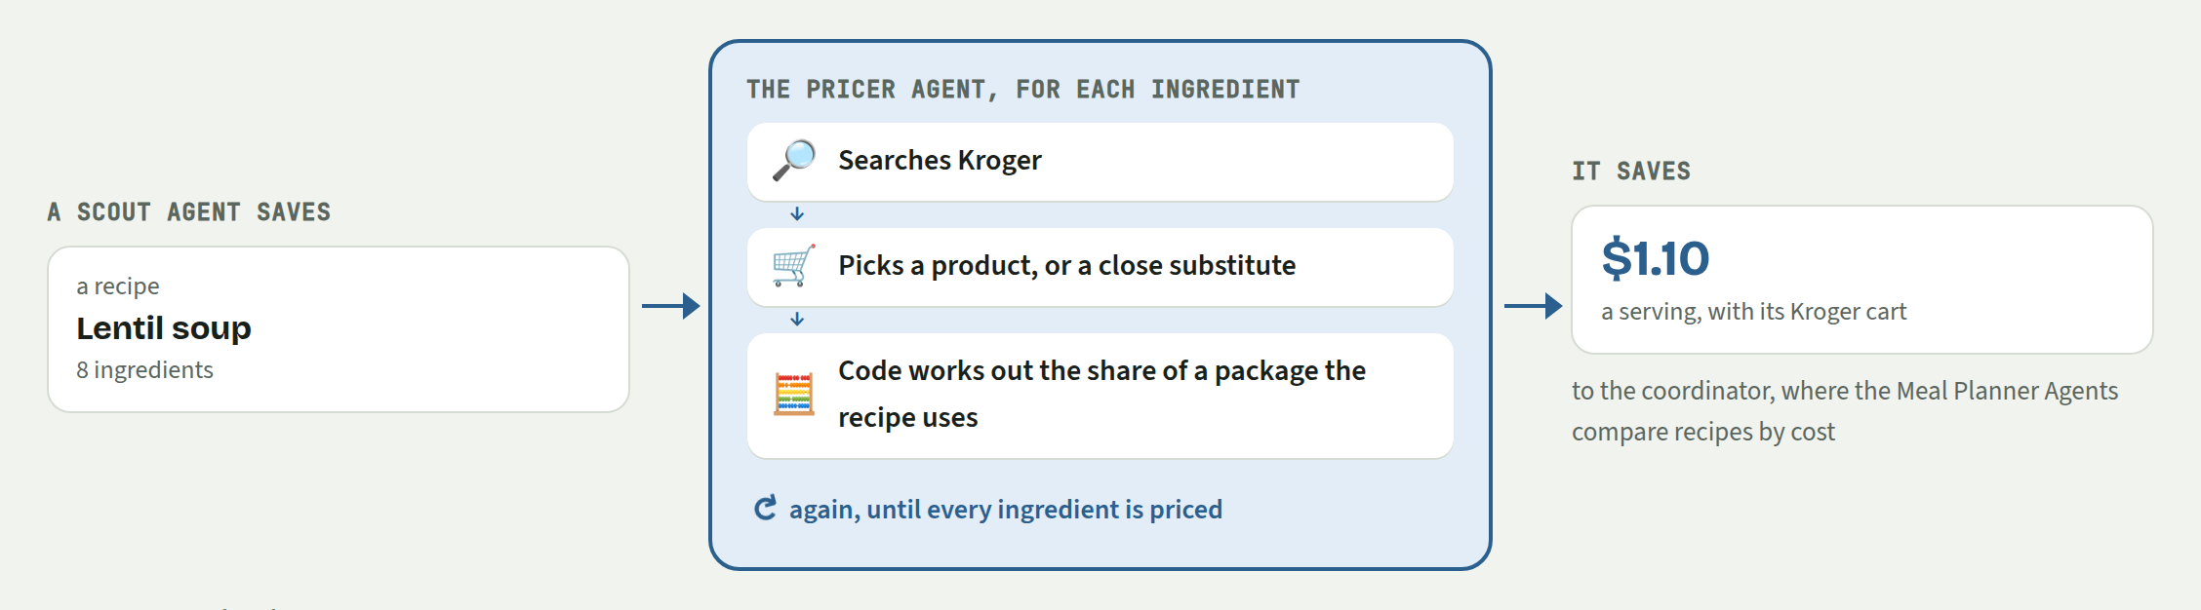
Source: Meal Squad site, Recipe Pricer page.
On the site’s Recipe Pricer page you can watch it work: every recipe the class saved, its cart and price, and each step the agent takes. You can filter the page by your group’s name.

Part 3: The Meal Planner (Agent 3)
If there’s time, build the Meal Planner in a new Lovable project. It reads the class’s priced recipes from the coordinator, drafts five dinners, asks the coordinator to check them against the budget and the class’s rules, fixes what fails, and saves the week for the Shopper Agent.

Figure 9 What the Meal Planner Agent does
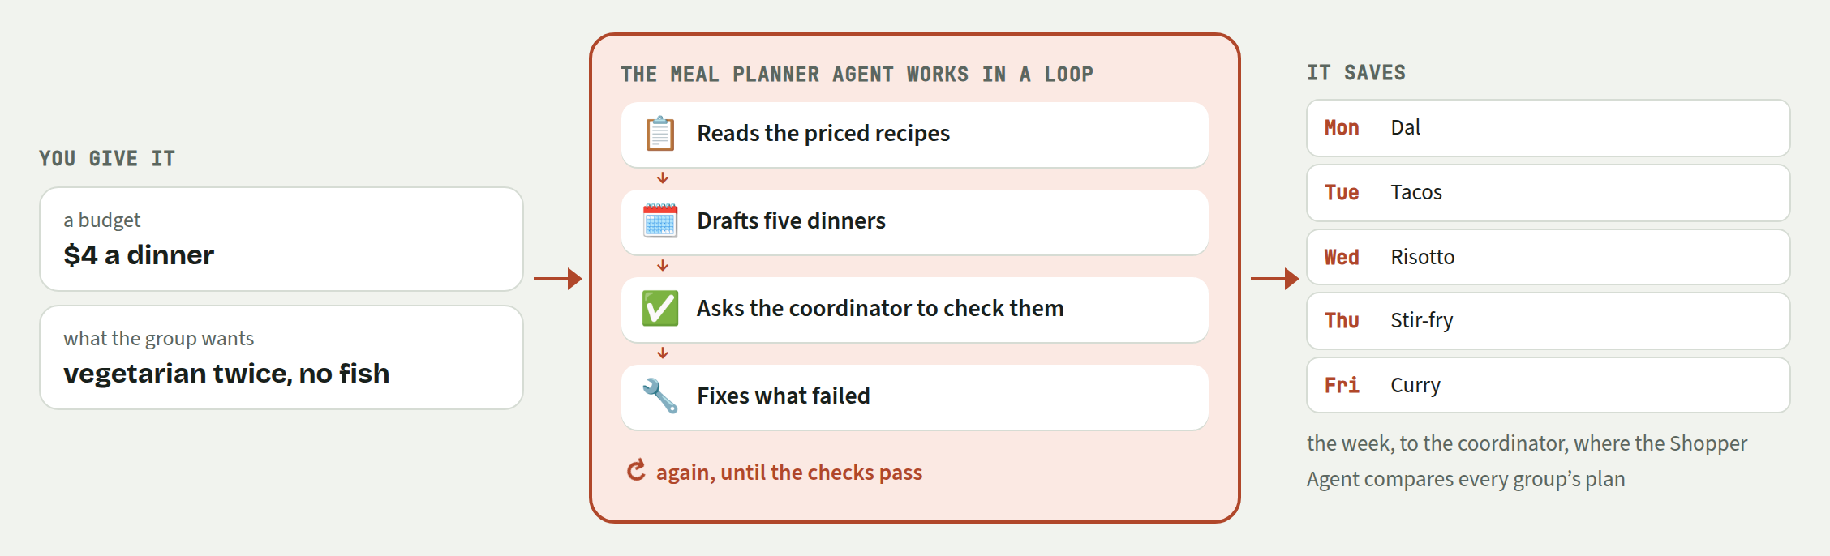
Source: Meal Squad site, Meal Planner page.

Step 1: Build the interface
Goal. Create the page where you enter a budget, dietary requirements and preferences, and where the week will appear. There is no AI, backend or recipe data yet.
Sample prompt (copy it into Lovable as it is, or change it)
Build a web app called “Meal Planner” for a class exercise.

The goal of Meal Planner is to plan five dinners, Monday through Friday, using recipes that Scout Agents have found and the Pricer Agent has priced. It will eventually use AI to:

- Take a budget, dietary requirements and preferences from the user
- Read the recipes saved by the class, with their prices
- Choose five dinners that are varied and affordable
- Save the plan through the coordinator so the rest of the class can see it

For now, build only the interface. Do not add AI, a backend, a database or connections to other services yet.

Include the following items:
- A number input for the maximum average budget per person per dinner, in US dollars (default: 4, minimum: 1)
- A text box with “Dietary requirements” (Examples: “vegetarian only”, “no pork”, “no peanuts”). Explain that these are hard constraints.
- A text box with “Preferences” (Examples: “we like spicy food”, “prefer quick dinners”). Explain that these are preferences, not hard requirements.
- A “Plan my week” button.
- A “What the Meal Planner Agent is doing” panel. Leave it empty for now.
- A “The week” panel with five empty cards:
Monday, Tuesday, Wednesday, Thursday and Friday.
- An empty outcome area that will eventually show one of:
- Valid plan found
- No feasible plan found
- Run failed

Nothing needs to happen when the button is pressed yet.

Make the page warm, inviting, responsive and accessible.

What you should see
- The page: the budget, dietary requirements and preferences boxes, the “Plan my week” button and five empty days. The button does nothing yet.
Things you can try
- Ask Lovable to change the colors or layout to make it your own.
Don’t spend too long polishing. You will change the interface as the agent develops.

Step 2: Connect to the coordinator
Goal. Connect the app to the coordinator’s MCP server, look at the actions (tools) it offers and use them to show the recipes the class has saved, with the prices the Pricer Agent worked out. There is no AI yet.
The class key never goes in a prompt. This step asks Lovable to create a secret. Lovable then shows a secure box where you paste the key.
Sample prompt (copy it into Lovable as it is, or change it)
Enable Lovable Cloud. Connect Meal Planner’s backend to the coordinator using MCP. The app itself talks to the coordinator while it runs. The MCP server is at this address: https://recipes-delta-red.vercel.app/api/mcp?agent=planner

For now, only establish the connection, discover the tools offered by the coordinator and use them to show the class’s recipes. Do not add an AI agent yet.

The coordinator requires two things on every request: our class key and our group name. All requests to the coordinator must be made from the backend.

Create a protected Lovable secret called CLASS_KEY and ask me to enter its value. Never place the class key in the page, browser code, logs or AI instructions. Our group name is [your group name].

Once you have established the connection:

- Show the connection status, including the group name the coordinator confirms.
- Explain the tools that are available and the information each one requires.
- Use the coordinator tool that explains how to work with the coordinator, and show its answer in a collapsible “How the coordinator works” section.
- Get all the recipes the class has saved that already have a price, and show them in an “Available recipes” table below the week: photo, name, cuisine, cost per serving and the groups that scouted it.

The coordinator’s answers are text with data inside: turn them into ready-to-show information in the backend, once. If a section can’t be shown, display a short message in that section instead of breaking the page.

If there are no priced recipes yet, say so plainly instead of showing an error.

What you should see
- A successful connection message
- The coordinator confirms your group name, e.g. “You’re connected as group team-3”. If it isn’t your group’s name, fix it before going on.
- The tools provided by the coordinator and a description of what each tool does
- How the coordinator works: the plan format, the checks and the limits
- A table of the class’s priced recipes, with the groups that scouted each one. If it is empty, the Scout Agents haven’t saved recipes yet or the Pricer Agent is still working on them.
Things you can try
- Read the checks the coordinator applies to every plan.
- Look for your connection on the Coordinator page.
- Discuss which tools the Meal Planner Agent should use, and in what order.
The Meal Planner never talks to the Scout Agents or the Pricer Agent directly. It reads their work from the coordinator, which stores the recipes and prices and describes how to use them.

Step 3: Add the Meal Planner Agent
Goal. Add an AI agent that learns how to work with the coordinator, chooses five dinners, asks the coordinator to check the plan, improves it and saves it so the rest of the class can see it.
Before you start: continue once “Available recipes” shows at least five priced recipes. If it doesn’t, tell the instructor.
Sample prompt (copy it into Lovable as it is, or change it)
Now turn the app into an AI Meal Planner using Lovable’s built-in AI.

At the start of every run, the app asks the coordinator which tools it offers, and gives them to the Meal Planner Agent as the coordinator describes them, with the same names, descriptions and inputs. Let the coordinator describe its own formats, checks and limits, every time the agent is run. Also give the Meal Planner Agent a way to end the run with a summary.

Pass the page’s inputs to the Meal Planner Agent (“none” for an empty box).

Goals and rules for the Meal Planner Agent:

- Plan five dinners, Monday to Friday, that meet the dietary requirements, follow the preferences where possible, and are varied and as cheap as possible within the budget.
- Spread similar dishes across the week: avoid the same type of food (the same cuisine, category or main ingredient) on consecutive days, and never three days in a row.
- When two choices are otherwise close, prefer the recipe more groups chose: popularity shows what the class likes.
- First use the coordinator tool that explains how to work with the coordinator, and follow what it says.
- The coordinator’s checks don’t cover dietary requirements or preferences: the Meal Planner Agent must check those itself, from each recipe’s ingredients.
- Never invent a recipe or a price.
- Check a draft with the coordinator before saving it. If a check fails, improve the plan and check again.
- Save the best plan once, then end the run. If no plan passes every check, save the closest one and explain why.

Run every tool the Meal Planner Agent asks for and return the complete result to it, including rejections: a rejection is feedback, not a crash. Stop when the agent ends the run, after 30 actions or after three minutes. The app must not save a plan the coordinator hasn’t checked during this run, or more than one plan per run.

Update the page:

- “Plan my week” starts the Meal Planner Agent and is disabled while it works
- “What the Meal Planner Agent is doing” shows its actions and the coordinator’s answers as they happen; make failed checks and rejections easy to spot without showing them as crashes
- “The week” shows the saved plan: for each day the photo, name, cost per serving, the groups that scouted it and why it was chosen; below the days, the average cost of a dinner against the budget and each check with ✓ or ✗
- The outcome: “Valid plan found” when the saved plan passes every check, “No feasible plan found” otherwise, or “Run failed” when the run stopped on an error or a limit, with the agent’s summary
- A link to the class Coordinator page (https://recipes-delta-red.vercel.app/coordinator) and credit to TheMealDB for the photos
- Keep “How the coordinator works” and “Available recipes” as collapsible sections

What you should see
- It drafts a plan, asks the coordinator to check it and changes dinners when a check fails.
- Its explanations say how the dinners meet your dietary requirements: the coordinator checks the budget and the class’s rules (see “The checks” below), not free-text requirements.
- Five dinners fill Monday to Friday, each showing which groups scouted it, with the average cost of a dinner against the budget and each check marked ✓ or ✗.
- The outcome: valid plan found, no feasible plan found, or run failed, with an explanation.
- The saved plan appears on the Coordinator page under your group.
Things you can try
- A tiny budget, such as $1 a dinner. Does it explain that it can’t be done, or pretend?
- A rule of your own, such as no dinner over 45 minutes.
- Change one Meal Planner Agent instruction and compare its behavior.
- Experiment with different instructions and goals, such as food from a different continent every day.
- Find a moment in “What the Meal Planner Agent is doing” where a tool’s answer changed the agent’s next move.
- Ask Lovable to add a shopping list: the ingredients of the five dinners, each listed once.
- Ask Lovable to keep a history of past runs you can reopen.
- Ask Lovable to test the app.
The important question is not only “Did it save a plan?” Also ask: “Did it fix the checks that failed, and are its explanations honest?”
Once your Meal Planner saves a plan, see the Shopper Agent on the site’s Shopper page, and every plan the class saved, with each check the coordinator ran, on the Coordinator page.

Part 4: The Shopper (Agent 4, Already Built)
The Shopper Agent compares the meal plans the Meal Planner Agents saved, chooses the one the class will cook, credits the group that made it, and does the class’s shopping: the week’s Kroger cart for it, for 50 people by default. It checks each product at Kroger that day, buys an ingredient that several dinners share only once, and replaces what the store no longer carries. It runs on the site: the instructor starts it, or it starts by itself once enough plans are saved. The class’s plan, the cart and why the Shopper Agent chose it appear on the site’s Shopper page.

Figure 10 What the Shopper Agent does
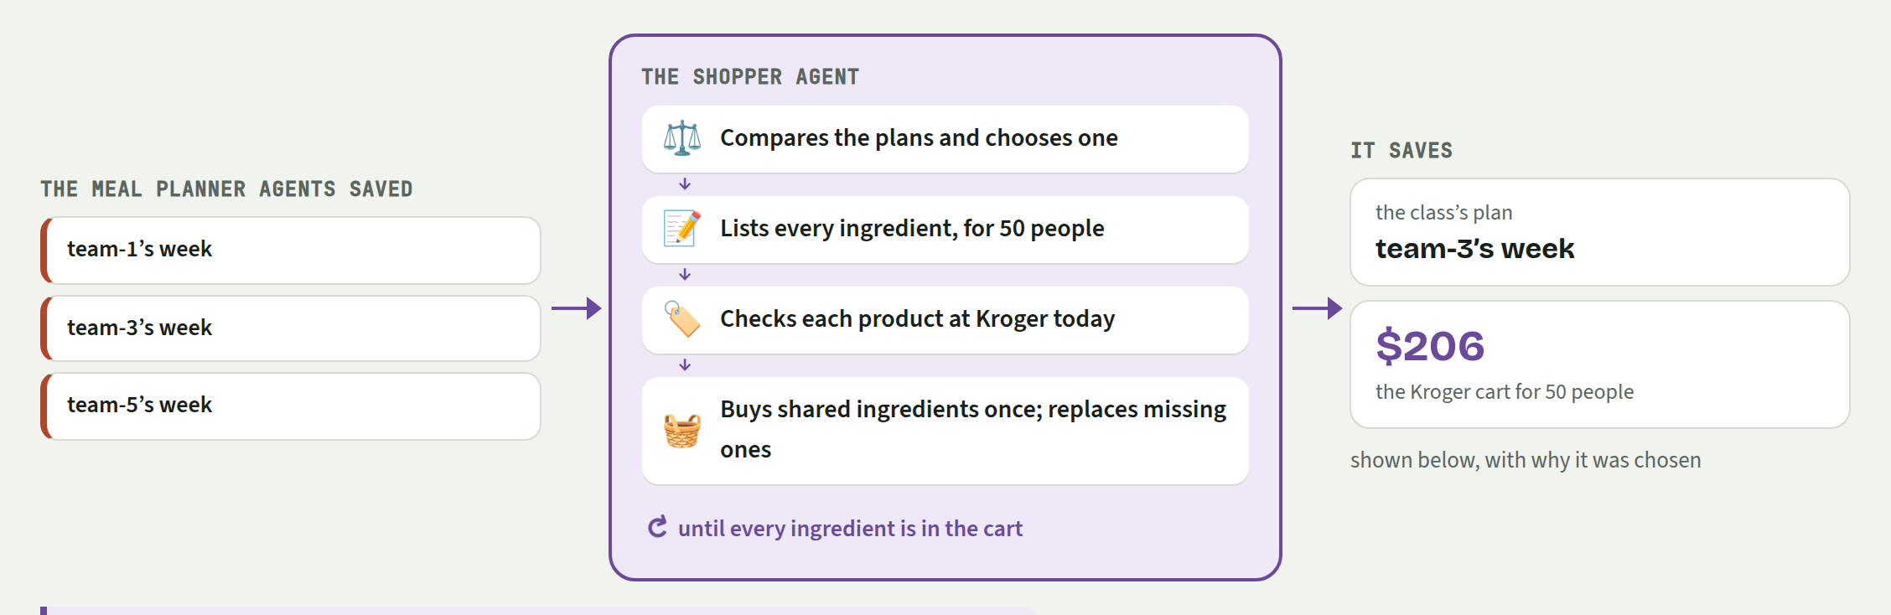
Source: Meal Squad site, Shopper page.

When Something Goes Wrong
A step that fails is part of the exercise. Tell Lovable what you expected and what happened instead, and paste any error message you see. Look at what the agent did (its trace) before changing anything; if a change made things worse, ask Lovable to go back to the previous version. You don’t need to start over.
Problem | What to do
“Missing or wrong class key” (error 401) | Re-enter the CLASS_KEY secret in Lovable, then ask: “Check that every request to the coordinator sends the header Authorization: Bearer followed by the CLASS_KEY secret.”
An error about “X-Group” (error 400) | The coordinator needs your group name on every request. Ask Lovable: “Send our group name in the header X-Group on every request to the coordinator.”
The coordinator rejected a recipe or a plan | That’s the coordinator doing its job, and the rejection lists every problem. A good agent reads the reasons, fixes them and tries again. If it keeps making the same mistake, paste the reason into Lovable and ask it to make sure the agent passes the rejection back to the AI.
A “CORS” error in the browser | Your page is calling the coordinator directly from the browser. Ask Lovable: “Move every call to the coordinator into a backend function.”
The agent stops early or goes round in circles | Look at the last few steps it took. Tell Lovable what it did and what it should have done instead, or make its instructions clearer.
Where can I see what my agent actually did? | On the site’s Coordinator page: every request your agent sends and the coordinator’s answer, live, including rejections and why. Filter by your group name.

Takeaways
Look back at the system the class built.
How agents work together
- One agent, one job. The Scout, Pricer, Meal Planner and Shopper Agents each do one thing well, and are easier to build, test and fix.
- The handoff is the design. A coordinator with a clear contract lets agents work together without ever talking to each other.
- Check, don’t trust. The coordinator checks every save and code does the arithmetic. The agent decides; the system verifies.
- Real data is messy. Missing products, substitutes, estimates, changing prices. Good agents label what they’re unsure of.
What to take into your own work
- Evaluate, don’t eyeball. Agents vary from run to run, and a small prompt change can shift what they do. Decide what good looks like, test on a fixed set of cases, and re-run them after every change.
- Read the traces. What an agent did, step by step, tells you more than what it says it did.
- Keep people in the loop. People decide when agents run, review their choices, and double-check before money is spent.
- Start small, then connect. One agent working end to end beats five half-built. Add the next when the handoff works.

